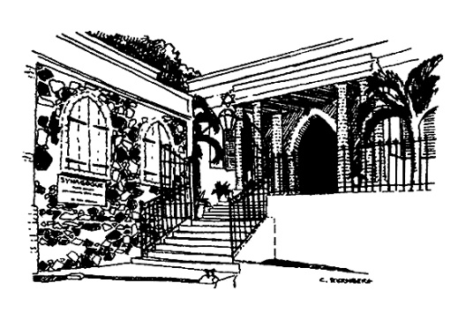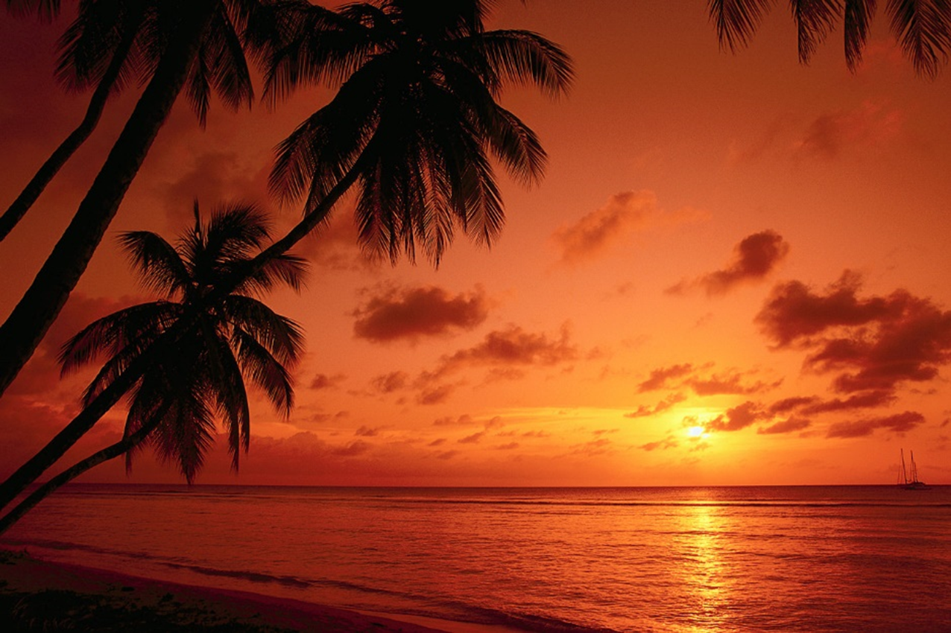

**Join Rabbi Michael Feshbach at the Hebrew Congregation of Saint Thomas for:**

8:00 PM: Gathering at Lilienfeld House in the back building; brief rehearsal for later.

8:30 PM: Baking project, something fun and sweet (with health-conscious options too).

9:00 PM: Teen talk. What’s all this to you? Do you have doubts or disagreements, questions about God, Israel, or Jewish life? And themes of the season: is anything so terrible it cannot be forgiven? How do you approach friends you may have hurt? Does this new year feel any different after the hurricanes?

9:30 PM: Teens change the robes of the Torah scrolls to the white mantles they wear during the High Holy Days.

10:00 PM: Teens carry Torah scrolls into the candlelit Sanctuary, lead Havdalah, participate in the mystical, candle-lit, spiritual service of Selichot.

For more information

or with questions please contact

The Hebrew Congregation

of St. Thomas

340-774-4312

[info@synagogue.vi](mailto:info@synagogue.vi)

For directions to the congregation click [here](http://synagogue.vi/about-us/visit-us/how-to-get-here/).

Calling all

Jewish teens on   
the Virgin Islands:

A request and opportunity  
for a very special evening

Selichot:  
A Candlelit Service  
of reflection and preparation

Saturday, September 1  
8:00 PM – 11 PM

Please wear white that night!

Calling all

Jewish teens on   
the Virgin Islands:

A request and opportunity  
for a very special evening

Selichot:  
A Candlelit Service  
of reflection and preparation

Saturday, September 16  
6:00 PM – 11 PM

Please wear white that night!